**Iron Chef**

**Alexander Maxey**

**Section 1**

**Pitch**

In this game, play as an iron-clad chef saving the Kingdom of Sustenance from the destructive rampage of the food monsters, and using this opportunity to prepare the finest meals from your slain enemies.

**Game Mechanics**

The player plays as the Iron Chef, an armored cook exploring the level and slaying various food monsters, culminating in a boss battle against a unique food enemy. The player fights enemies by running, rolling, slashing, or throwing weapons at enemies. In addition, the player collects augments after completing levels, allowing them to equip an augment before the next level, such as hot tamale bombs or upgrading their armor with rock candy, which improves their combat ability in a unique way. The player completes a level by returning to their starting cauldron, where the meal can be prepared. When a level is completed, the player is scored based on how well they collected the correct amount of ingredients for their dish and avoided the incorrect ingredients. If they pass the minimum score, they are offered their augment reward and can move on to the next level.

**Game Concept**

The Iron Chef is a retired-knight-turned-cook in this whimsical high fantasy setting. Food monsters have left their homes and are invading the Kingdom of Sustenance, and it is up to the Iron Chef to stop them. Armed with his magical cleaver, the Iron Chef must slay the food monsters and turn them into the ultimate meal. Each zone of the game will be themed around a different cultural food style or meal group, such as Breakfast, Lunch, Dinner, American, Mexican, Italian, etc. Each zone will have a few levels. As the player travels through the land, it becomes apparent that the food monsters were driven out of their home. In the final levels, the Iron Chef discovers that the Evil Vegan monsters, such as the dreaded Tofu Turkey, have taken over their land and driven them out. The Iron Chef must defeat these monsters so the original denizens can return home and leave the kingdom in peace and proving that the Iron Chef can prepare a perfect meal even with Evil Ingredients.

On a level by level basis, the Iron Chef is taking advantage of the massive food monsters’ presence to craft legendary meals from the freshest ingredients. The player must slay the monsters present in the level to craft the perfect meal, such as an omelet or a soup. By killing an enemy, the monster is absorbed into their dish through the magic cleaver, thereby adding it to the meal. They must ensure they do not add too much or too little of an ingredient and avoid ingredients that don’t go in a dish. One required ingredient will be acquired by defeating a mighty boss food.

**Target Audience**

The game’s targeted audience is the teenage to young adult demographic, between ages 13 – 24. The game will likely be rated T for teen under the ESRB.

**Section 2**

**Game Design**

**Game Mechanics**

The gameplay can be compared to Dark Souls or Breath of the Wild. The player must explore the level, fight the monsters found in the level, and defeat a powerful boss. The game begins to differentiate in that the player must think about what they kill to make the perfect dish, and that the world is much less open, and more level based. This gameplay is unique to its counterparts due to the fact that there is a punishment for killing too many enemies or the wrong enemies, requiring the player to strategize and work around instead of purely hacking and slashing. In addition, the game is more level oriented than open world, leading to a more contained and controlled game experience.

The game’s combat, much like the stated comparison games, has the player jog, sprint, jump, duck, block, and roll to move around the level and evade enemy attacks. The player will have two basic attack forms, a basic melee attack, and a basic ranged attack. By default, this will be swinging your cleaver and throwing a frying pan. The player will also have an augmentation power, which will be acquired throughout the different levels and chosen at the level’s start. This might be a passive effect to make you stronger, or an active effect like an attack or temporary buff/debuff.

Outside of combat, the player will explore the level, looking for the food types they need and the eventual boss. The player can also decide to eat some of the ingredients they gathered to restore some hit points. The player can only do this so many times in a level, so they must be careful when they use it and what ingredient they choose to eat. The player’s will eventually return to their cauldron at the start point, so they can conclude the level.

The player will encounter several different types of enemies. Most enemies will have their basic dodgeable attack, and perhaps one or two powers, and will be required for your dish. Some of these enemies will not be a required component for your dish and killing them will give a detriment to your final score. These enemies will usually be avoidable in some way, such as being big and slow so the player can go around, or not damaging to the player, and merely a nuisance, so the player can choose to deal with the annoyance rather than kill the monster. There will be one boss in every level, each one with a unique power set, such as an egg that can roll and bounce around his fight area.

After a level is completed, the game will evaluate what the player collected for the level. The player will then be scored based on how well they did, and if the minimum score is met, the player will be ready to advance to the next level and may unlock a new augment for future levels.

**Game Structure**

The game will be structured in levels, following a linear path. Before a level begins and when a level ends, a quick dialogue or cutscene might play to help further the narrative, similar to the way Dungeons 3 has 2D art with a narrator explaining events between some levels. The levels encountered will be structured into different sub-groups, like stages in other games. These might be food groups or meal types, like breakfast lunch or dinner. In this way we can theme our levels and environments, such as a morning light for the breakfast levels, a dark spooky forest for the midnight snack levels, etc.

**Game Controls**

The game is targeted for PC and Console, so it must work with mosue/keyboard and controller. The game will follow the common control schemes for these games, like LStick/WASD to move, Triggers/MouseClick for basic attacks, etc. The game will be made in the Unity game engine, which allows a very flexible input system to manage the different control schemes.

**Game Visuals**

The player will view the 3D world through a 3rd Person Shooter type perspective, fighting monsters and bosses in the world. The atmosphere is bright and optimistic, with a non-serious tone.  The game’s concept is more whimsical and silly than it is serious, so it would follow that the art and audio style supports this whimsical fantasy setting. Cartoony characters, enemies and terrain paired with exciting, upbeat music should support this core concept. As the character idles or moves around the game, it should be clear he has an enthusiastic, almost bouncy spring to his step. The monsters are menacing in their size, teeth, and monstrous attributes, but are not grotesque or anxiety inducing as darker games like Dark Souls can be. The model quality/art style can be compared to Dungeon Defenders 2, in which it is cartoonish.

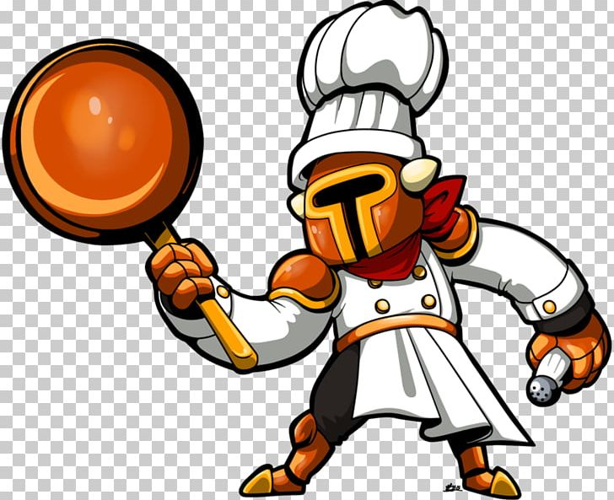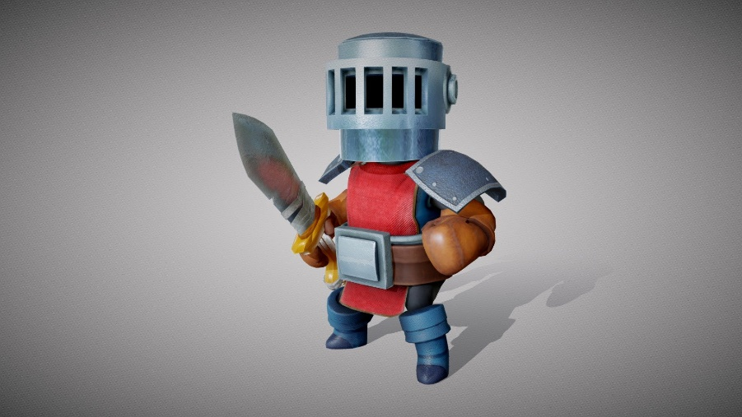Pictured here are some concept art pieces from online.

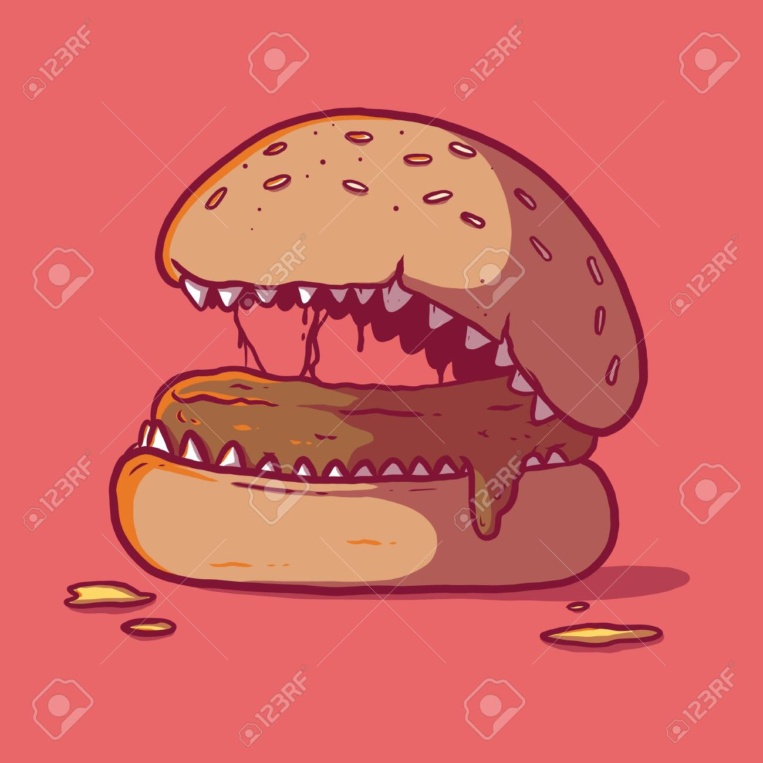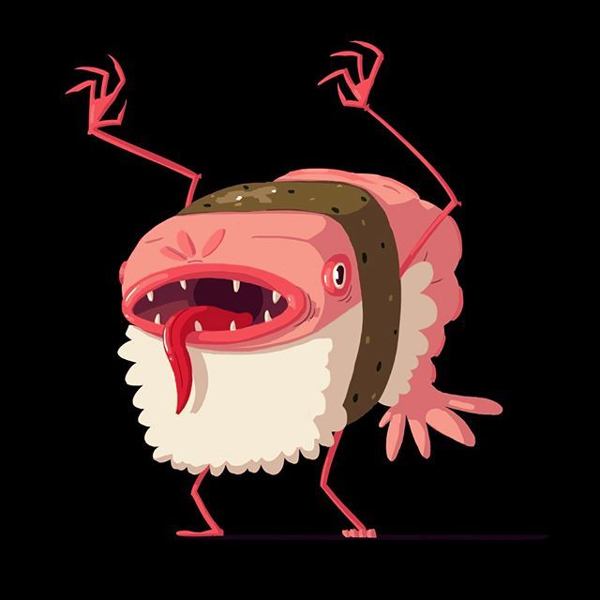

Pictured here is the target player view/combat based on other games:: Dark Souls, Breath of the Wild, Smite

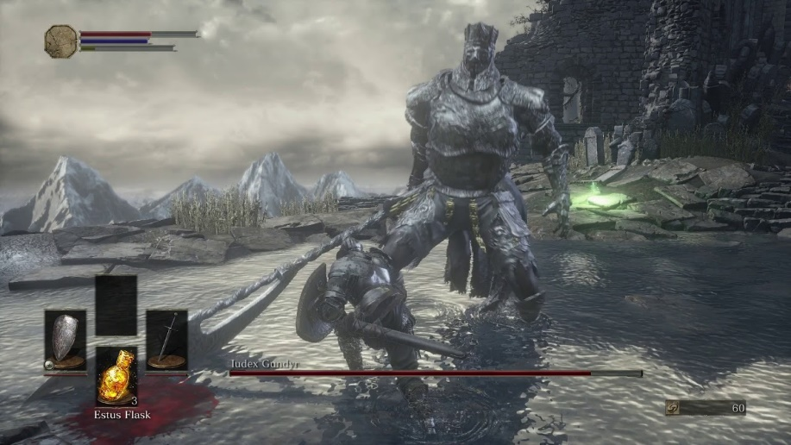

Pictured here is Dungeon Defenders 2, the reference in game art style

